
System Analysis and Design
Inf319

[Freelancer Marketplace]

Project Teamwork
No | Name | Role
 | Youssef Mohamed | Introduction  Problem Statement  Aim & Scope  Motivation  Project Idea  System Development Methodology  System Request  System Proposal.
 | Jana Hassan | Project Plan  Feasibility analysis  Business model  List of Functional  Non-Functional requirements  Gantt Chart  Requirements Elicitation Techniques
 | Seif Ahmed | Context Data Flow Diagram.  Use case Figure  Tables for Use cases  Context Diagram  Dataflow Diagram with various Levels
 | Omar Mohamed | Design Strategy  Test Scenarios.  The Alternative Matrix  Activity Diagram.
 | Diaa Eldeen | User Interface Design.  ERD Diagram  system Acquisition

Table of Contents 
Contents
Project Teamwork 2
Introduction 4
Project Idea 5
System Request 6
Feasibility Analysis 8
System Development Methodology 11
Project Plan 12
Gantt Chart 15
Business Model 16
Requirements Elicitation Techniques 17
System Functional Requirements 21
System Nonfunctional Requirements 24
System Proposal 26
Use case Figure 29
Tables for Use cases 30
Context Diagram 34
Dataflow Diagram with various Levels 35
Activity Diagram 38
ERD Diagram 39
System Acquisition Strategy 40
The Alternative Matrix 40
Test Scenarios 43
User Interface Design 45

Introduction

With the rapid growth of the digital economy and the increasing adoption of remote work, freelancing has become one of the most important employment models worldwide. Many companies and individuals now depend on freelancers to complete tasks in areas such as web development, graphic design, digital marketing, and content creation.
Problem Statement
Despite the popularity of freelancing platforms, several challenges still exist in the current freelance marketplace. Clients often face difficulties in identifying skilled and trustworthy freelancers with verified experience and reliable portfolios. At the same time, freelancers, especially beginners, struggle to gain visibility, build credibility, and compete with more established professionals. Additionally, some existing platforms suffer from issues related to unclear rating systems, lack of transparency, and inefficient communication between clients and freelancers.
Aim & Scope
This project proposes the development of a Freelancer Marketplace System, which aims to provide a structured and user-friendly environment for connecting freelancers with clients. The system will organize services in a clear and categorized way, allowing clients to easily search for the right professionals based on skills, experience, and project requirements.
Motivation
Furthermore, the platform will include transparent evaluation mechanisms such as reviews to improve trust and accountability between users. By simplifying the hiring process and improving communication, the system aims to support professional collaboration and contribute to the continuous growth of the freelance economy.

Project Idea
The Freelancer Marketplace System is an online platform designed to efficiently connect freelancers with clients who need professional services. The system aims to simplify the hiring process while ensuring transparency, trust, and effective communication between both parties.
The platform allows freelancers to create professional profiles where they can present their skills, experience, portfolios, and services. These profiles are organized into categories such as software development, graphic design, digital marketing, and content writing, making it easier for clients to find the right freelancers based on their needs.
On the other hand, clients can post projects that include details such as project descriptions, required skills, budget ranges, and deadlines. Freelancers can then review these projects and submit proposals explaining how they will complete the work and the cost involved.
To ensure fairness and reliability, the system will include a review mechanism where both clients and freelancers can evaluate each other after completing a project. This feature helps build trust within the platform and improves the quality of collaboration.
Overall, the goal of the system is to create a secure, transparent, and easy-to-use marketplace that improves the freelance hiring process and supports long-term professional relationships between freelancers and clients.

System Request
System Request — Freelancer Marketplace System
Project Sponsor:
Business Development Department
Business Need:
The increasing demand for freelance services requires a reliable digital platform that connects freelancers with clients efficiently. Many existing platforms lack transparency and make it difficult for clients to verify freelancer skills, experience, and portfolios. In addition, new freelancers often struggle to gain visibility and build trust with potential clients. Therefore, a structured and user-friendly freelancer marketplace system is needed to simplify the hiring process, improve communication, and create a trustworthy environment for both freelancers and clients.
Business Requirements
The proposed system should provide the following functions:
- Allow freelancers to create professional profiles that include their skills, experience, portfolios, and service categories.
- Allow clients to post projects including project descriptions, required skills, budgets, and deadlines.
- Enable freelancers to browse available projects and submit proposals to clients.
- Provide a search and filtering system to help clients find freelancers based on skills and experience.
- Include a review system to allow users to evaluate each other after project completion.
- Provide secure communication between freelancers and clients through messaging or notifications.

Business Value
We expect that the Freelancer Marketplace System will improve the efficiency of connecting freelancers with clients by providing a structured and easy-to-use platform for hiring professional services. The system will allow businesses and individuals to quickly find qualified freelancers, while enabling freelancers to showcase their skills and gain more work opportunities.
We also expect the platform to create new revenue opportunities through service commissions, premium memberships, and promotional features for freelancers. Additionally, as more users join the platform, the system will strengthen professional collaboration and support the growth of the digital freelance economy.
The platform may also increase cross-service engagement, where clients who hire freelancers for one task may return to the platform for additional projects in areas such as design, development, or marketing.
Conservative estimates of tangible value to the platform include the following:
• $800,000 in revenue from service commissions on completed projects
• $500,000 in revenue from premium freelancer memberships and featured profiles
• $250,000 in revenue from promoted job listings and advertisements
Special Issues or Constraints
- Ensuring strong security measures to protect user data and personal information.
- Preventing fake reviews or manipulation of the rating system.
- Managing disputes between freelancers and clients in a fair way.
- Ensuring the system can handle a growing number of users and projects as the platform expands.
- Maintaining system performance and reliability for continuous online access.

Feasibility Analysis
Technical Feasibility
The Freelancer Marketplace System is technically feasible because it will be developed using modern and widely adopted web technologies suitable for scalable online platforms.
The system will utilize front-end technologies such as HTML, CSS, and JavaScript, along with backend frameworks such as Node.js and Express, and a database management system such as MySQL or MongoDB. These technologies provide strong support for building secure, responsive, and high-performance web applications.
Key system features including user authentication, messaging systems, advanced search filtering, escrow-based payment processing, and review management can be implemented using proven architectural patterns and existing software libraries.
Additionally, cloud hosting platforms and scalable infrastructure services will support deployment, performance optimization, and future growth of the platform.
The development team possesses the required technical expertise in software engineering, database design, system architecture, and web application security to successfully implement the system.
Therefore, the project is technically feasible.

Economic Feasibility
The development of the Freelancer Marketplace System is economically viable due to manageable development costs and strong long-term revenue potential.
Initial investment will include:
- Development resources and infrastructure setup
- Cloud hosting and database services
- Domain registration and deployment tools
- Integration costs for secure payment gateway services
- System maintenance and support costs
Despite these costs, the system is expected to generate sustainable revenue through multiple business streams including:
- Commission fees on completed freelance projects
- Premium memberships for freelancers
- Sponsored project listings and promotional services
Based on conservative financial projections, the platform may generate substantial revenue growth as user adoption increases. This creates a favorable return on investment and supports the financial feasibility of the project.

Organizational Feasibility
The project is organizationally feasible as it aligns with the strategic objectives of the organization to expand digital service offerings and support remote professional collaboration.
The development team will follow Agile methodology to ensure continuous delivery, stakeholder involvement, and rapid adaptation to changing requirements. Regular sprint reviews and performance evaluations will ensure that development progress remains aligned with business goals.
From a user adoption perspective, the system addresses real challenges faced by freelancers and clients in existing marketplaces, increasing the likelihood of acceptance and engagement.
Management support, clear project governance, and defined development responsibilities further contribute to the successful implementation of the system.
Therefore, the project is organizationally feasible.

System Development Methodology

For the development of this project, the Agile methodology was selected. Agile is widely used in modern software development because it allows teams to develop systems in small iterations while continuously improving the product based on feedback.
The Freelancer Marketplace System involves two main types of users: freelancers and clients. Since the requirements and expectations of these users may evolve during development, Agile provides the flexibility needed to adapt to changes and improve the system gradually.
Adapting to Changing Requirements
Features such as advanced search filters, rating systems, messaging tools, and proposal management may need adjustments after initial testing. Agile allows developers to update and refine these features during each development cycle without disrupting the entire system.
Learning from User Feedback
The system can initially be released as a Minimum Viable Product (MVP) that contains the most essential features. After deployment, feedback from users can be collected and used to improve the platform in future iterations.
Incremental Development
The system will be developed in separate modules or components. Each module will focus on specific functionality such as user registration, profile management, project posting, proposal submission, and review systems. These modules will be implemented and tested during different development sprints.
Early Detection of Problems
Agile development encourages frequent testing throughout the development process. This approach helps identify technical issues and usability problems early, reducing the risk of major errors appearing in the final version of the system.
Continuous Collaboration
Regular meetings and progress reviews will ensure that the development team remains aligned with the project goals and user requirements. This continuous communication helps maintain the quality of the system and ensures that the final product meets the expectations of both freelancers and clients.

Project Plan
Project Duration
Total Estimated Project Duration: 12 Weeks
The project will be executed using Agile methodology with iterative development cycles.
Phase 1 — Requirements Analysis (Weeks 1–2)
- Identify business stakeholders and user needs
- Conduct requirement workshops and stakeholder interviews
- Analyze competing marketplace platforms
- Define functional and non-functional requirements
- Finalize System Requirements Specification
Deliverable: Approved Requirements Documentation
Phase 2 — System Design (Weeks 3–4)
- Define system architecture and module structure
- Design database schema and data relationships
- Develop UI/UX wireframes and navigation workflows
- Prepare system diagrams (Use Case, DFD, ERD)
Deliverable: System Design Specification
Phase 3 — Development (Weeks 5–9)
Development will be organized into Agile sprints:
Sprint 1
- User registration and authentication
- Role-based access control

Sprint 2
- Freelancer profile and portfolio management
Sprint 3
- Project posting and proposal submission modules
Sprint 4
- Messaging system and real-time notifications
Sprint 5
- Rating and review system
- Advanced search and filtering features
Deliverable: Functional integrated system modules
Phase 4 — Testing and Quality Assurance (Weeks 10–11)
- Functional testing
- Integration testing
- Performance testing
- Security testing
- User Acceptance Testing
Deliverable: Stable and optimized system version
Phase 5 — Deployment and Project Closure (Week 12)
- Deploy system to production environment
- Prepare technical documentation and user manuals
- Conduct system demonstration and stakeholder review
Deliverable: Fully operational system

Gantt Chart
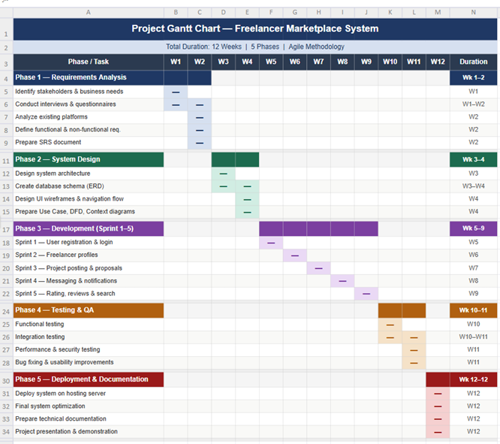

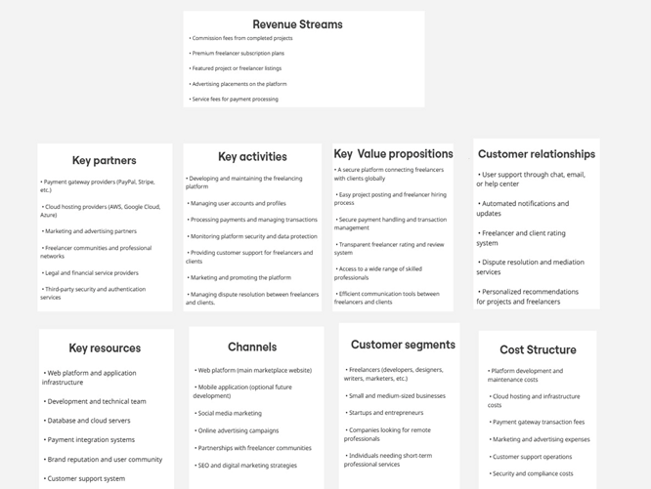
Business Model

Requirements Elicitation Techniques
1. REQUIREMENTS ELICITATION
This section describes the techniques used to gather requirements for the Freelancing Marketplace system. The objective was to understand user needs, existing platform behaviour, and industry standards.
1.1 Interviews
Method Description:
Semi-structured interviews were conducted with individuals familiar with freelancing platforms to gather qualitative insights about user needs and challenges.
Participants
A small group of users with experience in freelancing platforms such as Fiverr and Upwork was consulted, including both freelancers and clients.
Interview Questions
Freelancers:
What platforms have you used for freelancing?
What challenges do you face when finding projects?
How do you communicate with clients?
What features influence your decision to apply for a project?
What issues have you faced regarding payments or trust?
Clients:
What is your purpose for using freelancing platforms?
What challenges do you face when hiring freelancers?
How do you evaluate freelancer profiles?
What factors affect your hiring decision?
What improvements would you suggest?
Findings:
Freelancers often struggle with finding suitable and clear projects
Clients rely heavily on ratings, portfolios, and reviews
Communication delays are a common issue during project execution
Secure payment systems are considered essential by both parties
Users prefer a more transparent hiring process
1.2 Questionnaires
Method Description
An online questionnaire was distributed to individuals with varying experience in freelancing platforms to collect general user preferences and expectations.
Questionnaire Structure:
Section A: User Profile
Role: Freelancer / Client / Both / No experience
Frequency of platform usage: Occasionally / Sometimes / Regularly
Section B: Features
Important features (multiple choice):
Project posting
Search and filtering
Secure payments
Messaging system
Ratings and reviews
Preferred payment method:
Fixed price
Milestone-based
Hourly
Section C: Experience
Challenges faced when using freelancing platforms
Suggested improvements
Findings:
Secure payment systems are the most important feature
Milestone-based payments are preferred for better control
Search and filtering significantly affect usability
Ratings and reviews strongly influence hiring decisions

1.3 Observation
Method Description
Existing freelancing platforms were analysed through direct observation of their workflows to understand system behaviour and key features.
Platforms Observed
Upwork
Fiverr
Observed Workflows
Clients post detailed job listings
Freelancers submit proposals
Clients review profiles and proposals
Contracts are created with milestone payments
Freelancers create service listings (gigs)
Clients search and purchase services directly
Orders are completed through delivery and revisions
Findings
Upwork is based on a bidding model
Fiverr is based on a service marketplace model
Both systems depend heavily on trust and ratings
Search and filtering are essential features
Secure payment handling is integrated into both platforms

1.4 Document Analysis
Method Description
Document analysis was conducted using academic papers, industry articles, and official platform documentation to understand freelancing marketplace systems.
Sources Reviewed
Official documentation from Upwork and Fiverr
IEEE Xplore research on gig economy systems
ACM Digital Library publications on online marketplaces
Industry articles from Medium and Towards Data Science
Payment system documentation from Stripe and PayPal
References:
https://support.upwork.com
https://www.fiverr.com/support
https://ieeexplore.ieee.org
https://dl.acm.org
https://stripe.com/connect
https://www.paypal.com/business/platforms-marketplaces
https://towardsdatascience.com

Conclusion
The analysis confirms that freelancing platforms rely on structured user roles, secure payment systems, and trust-based mechanisms such as ratings and reviews. These insights directly guided the definition of system requirements for the proposed Freelancing Marketplace.

System Functional Requirements
Functional requirements describe what the system should do and the features it must provide.
2.1 User Management
- The system shall allow users to edit and update their profiles, including bio, skills, portfolio, and payment methods.
- The system shall allow admin users to manage all accounts, including approving freelancers, removing users, and monitoring platform activity.
2.2 Freelancer Features
- Freelancers shall be able to create and edit their professional profiles including photo, bio, skills, portfolio, experience, certifications, hourly rate, and services offered.
- Freelancers shall be able to list services with pricing packages, delivery times, add-ons, and FAQs.
- Freelancers shall be able to apply to posted projects by submitting proposals including a message, price bid, estimated timeline, and sample work.
- Freelancers shall be able to track project progress through milestones, status updates, and file uploads.
- Freelancers shall receive notifications for new projects, messages, or proposal acceptance.
- Freelancers shall be able to receive ratings and reviews after project completion.
2.3 Client Features
- Clients shall be able to post projects including title, description, budget, deadline, required skills, and file attachments.
- Clients shall be able to browse freelancers and services using filters such as skill, rating, price, experience, and category.
- Clients shall be able to hire freelancers by accepting proposals.
- Clients shall be able to communicate with freelancers through a messaging system with file sharing.
- Clients shall be able to rate and review freelancers after project completion.

2.4 Admin Features
- Admin shall be able to manage users, including approving freelancer accounts and removing fraudulent accounts.
- Admin shall be able to monitor transactions and disputes between freelancers and clients.
- Admin shall be able to view platform analytics, including active users, posted projects, and popular services.
2.5 Project & Task Management
- The system shall allow project milestone creation and tracking.
- The system shall allow uploading and sharing project files between clients and freelancers.
- The system shall allow revision requests and project status updates.
2.6 Search & Filtering
- The system shall allow users to search freelancers and services by category, skills, ratings, price, delivery time, and experience.
- The system shall provide advanced filtering options to improve matching efficiency.
2.7 Notifications
The system shall notify users about important events including:
- New messages
- Proposal acceptance
- Project milestone updates
- Payment updates
2.8 Payments
- The system shall allow clients to pay freelancers through a secure payment gateway.
- The system shall implement an escrow payment system to protect both freelancers and clients.
- The system shall generate payment invoices and transaction history.
2.9 Ratings & Reviews
- Users shall be able to rate and review each other after project completion.
- The system shall display average ratings on freelancer profiles and services.

System Nonfunctional Requirements
Non-functional requirements describe how the system performs and operates.
3.1 Authentication Requirements (Login & Registration)
- The system shall allow users to register accounts as Guest, Freelancer, or Client.
- The system shall allow users to log in using email and password or Google authentication.
- The system shall validate all registration fields before creating a user account.
- The system shall prevent duplicate accounts using the same email address.
- The system shall provide password recovery functionality through email verification.
3.2 Performance
- The system shall load any page under normal traffic conditions.
- Search results shall be returned within few seconds.
- The system should support much user as the system could.
3.3 Reliability & Availability
- The system shall perform automatic daily backups to prevent data loss.
- The system shall handle transaction failures gracefully and allow users to retry failed payments.
3.4 Security
- The system shall encrypt user passwords and sensitive data.
- All communication shall use HTTPS encryption.
- The system shall implement role-based access control for freelancers, clients, and admins.
- The system shall protect against SQL injection, XSS, and CSRF attacks.
- The system shall allow users to reset their password if forgotten.

3.5 Usability
- The system shall provide a responsive interface compatible with desktop and mobile devices.
- Key actions such as posting projects, applying to projects, and making payments should be completed within few clicks.
- The system shall provide help guides and tooltips for new users.
3.6 Maintainability
- The system shall follow modular architecture to support easy maintenance and upgrades.
- Code shall follow industry coding standards and documentation practices.
3.7 Scalability
- The system shall support growth in users, and projects without major performance degradation.
- The system shall support horizontal scaling of servers and databases.
3.8 Compliance
- The system shall comply with data protection and privacy regulations such as GDPR where applicable.
- The platform shall provide accessible Terms of Service and Privacy Policy to all users.

System Proposal
Project Title: Freelancer Marketplace System
Prepared By: Freelancing Marketplace | Date: 20/2/2026
Executive Summary
Freelancing has become a significant part of the global digital economy, allowing businesses and individuals to access professional services remotely. However, many freelancers struggle to gain visibility and trust, while clients often face difficulties in identifying qualified professionals with verified skills and reliable portfolios.
This project proposes the design and implementation of a Freelancer Marketplace System, a web-based platform that connects freelancers and clients in a structured and transparent environment. The system will allow freelancers to create professional profiles, showcase their skills and portfolios, and apply for projects posted by clients. Clients will be able to search for freelancers, post project requirements, review proposals, and hire suitable professionals.
The platform will also include rating and review mechanisms to ensure trust and accountability between users. By simplifying the hiring process and improving communication, the system aims to support professional collaboration and improve efficiency in freelance service marketplaces.
Purpose Statement
The purpose of this project is to design, develop, and implement a web-based Freelancer Marketplace System that facilitates efficient interaction between freelancers and clients, improves transparency in hiring, and provides an organized platform for managing freelance projects.
Deliverables (Objectives)
• System requirements analysis and documentation
• System design including database structure, user interface, and architecture
• Development of the freelancer marketplace platform
• Implementation of freelancer profiles and portfolio management
• Implementation of project posting and proposal submission features
• Implementation of a review system
• Development of secure user authentication and communication features
• System testing and evaluation
• Final project report and system demonstration

Success Criteria
Project success will be evaluated based on the following criteria:
• Clients can post projects and receive proposals from freelancers
• The platform provides reliable communication between freelancers and clients
• The rating and review system improves transparency and trust
• The system functions efficiently and meets user requirements
• The final system demonstrates usability, reliability, and scalability
Method Approach
The project will follow the Agile Software Development Methodology to allow incremental development and continuous improvement. The system will be developed in several modules, including user registration, freelancer profile management, project posting, proposal submission, and rating systems.
Development will proceed through multiple iterations (sprints), where each module will be designed, implemented, and tested separately. Feedback collected during each phase will be used to improve the system and ensure that it meets user needs effectively.
Resource Requirements
People
• Development team (Computer Science students)
• Project supervisor / course instructor
• Test users for system evaluation
Hardware
• Personal computers for development and testing
• Internet connection for hosting and testing the platform
Software
• Programming languages and frameworks (such as HTML, CSS, JavaScript, and backend technologies)
• Database management system (such as MySQL)
• Development tools and code editors
Third party
•Payment gateway (Payment Gateway)
Risk and Dependencies
Several risks may affect the successful completion of the project:
• Technical challenges in implementing secure communication between users
• Ensuring fairness and accuracy in the rating and review system
• Managing potential performance issues when handling multiple users and projects
• Limited development time within the academic semester
• Dependency on reliable hosting and database services
These risks will be mitigated through careful system design, regular testing, and proper project management.
To Be Completed by Appropriate Manager
Project Manager: Development Team Leader

Use case Figure
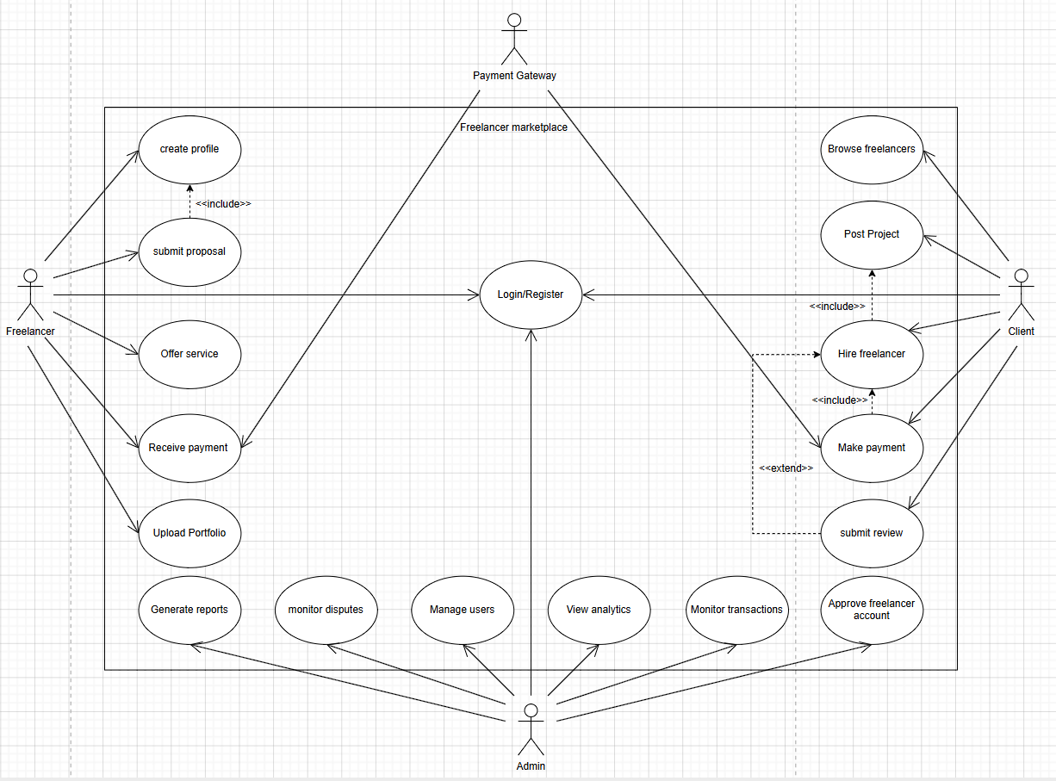

Tables for Use cases
Use case name: Post project |  | Id | UC-01 | Priority: High
Actor: Client
Description: Client creates and publishes a new project listing on the Marketplace, specify project title, description, required skills, budget, and deadline so freelancers can discover and submit proposals.
Trigger: Client clicks 'Post a Project' button from the dashboard.
Type: External
Preconditions:
1. Client must be registered in the system.
2. Client must be logged in.
3. Client must have a verified account.
Normal course:
1. Client navigates to the 'Post a Project' page.
2. Client enters project title, description, required skills, budget range, and deadline.
3. Client selects the project category.
4. Client clicks the 'Submit' button.
5. System validates all required fields.
6. System publishes the project listing on the marketplace.
7. System notifies matching freelancers about the new project.
8. System redirects Client to the project management dashboard.
Alternative courses:
5a. If required fields are missing:
5a.1. System highlights incomplete fields with an error message.
5a.2. Client corrects the fields and resubmits.
5b. Client clicks 'Save as Draft' instead of Submit:
5b.1. System saves the project as a draft.
5b.2. Client can return later to editing and publish.
Post conditions:
1. The project is listed and visible to freelancers on the marketplace.
2. Freelancers matching the required skills receive a notification.
3. The project appears in the Client's project dashboard.
Exceptions:
E1. Session timeout: If the Client's session expires mid-form, the system redirects to login. Draft data may be lost.
E2. Server error: If the system fails to publish, an error message is shown, and the Client is prompted to retry.
Summary:
The Client posts a project on the marketplace by filling in project details. The system validates and publishes the listing, notifying relevant freelancers.
Input | Source |  | Output |  | Destination
Project title, description, skills, budget, deadline | Client (via web form) |  | Published project listing, freelancer notifications |  | Marketplace database, Notification service

Use case name: Submit Proposal |  | Id | UC-02 | Priority: High
Actor: Freelancer
Description: Freelancer browses available project listings and submits a proposal to a chosen project, including a cover letter, proposed price, and estimated delivery timeline, to be considered for the project by the Client.
Trigger: Freelancer clicks 'Submit a Proposal' on a project listing page.
Type: External
Preconditions:
1. Freelancer must be registered and logged in.
2. Freelancer must have a completed profile (Create Profile use case).
3. Selected project must be open and accept proposals.
Normal course:
1. Freelancer browses or searches the available project listings.
2. Freelancer selects a project to view its full details.
3. Freelancer clicks 'Submit a Proposal'.
4. Freelancer enters a cover letter, bid amount, and estimated delivery time.
5. Freelancer clicks 'Send Proposal'.
6. System validates the proposal fields.
7. System saves the proposal and links it to the selected project.
8. System sends a notification to the Client about the new proposal.
9. System confirms submission to the Freelancer.
Alternative courses:
6a. If required fields are empty:
6a.1. System highlights missing fields.
6a.2. Freelancer fills in the missing information and resubmits.
3a. Freelancer has already submitted a proposal for this project:
3a.1. System alerts the Freelancer that a proposal already exists.
3a.2. System offers the option to edit the existing proposal instead.
Post conditions:
1. The proposal is saved in the system and linked to the project.
2. The Client receives a notification about the new proposal.
3. The proposal appears in the Freelancer's 'My Proposals' dashboard.

Exceptions:
E1. Project closed: If the project was awarded or closed before submission, the system notifies the Freelancer that proposals are no longer accepted.
E2. Session timeout: Freelancer is redirected to login; unsaved proposal data may be lost.
Summary:
The Freelancer submits a proposal (cover letter, bid, timeline) for an open project. The system saves it and notifies the Client.
Input | Source |  | Output |  | Destination
Cover letter, bid amount, estimated delivery time | Freelancer (via proposal form) |  | Saved proposal, client notification, submission confirmation |  | Project proposal database, Client notification service

Context Diagram

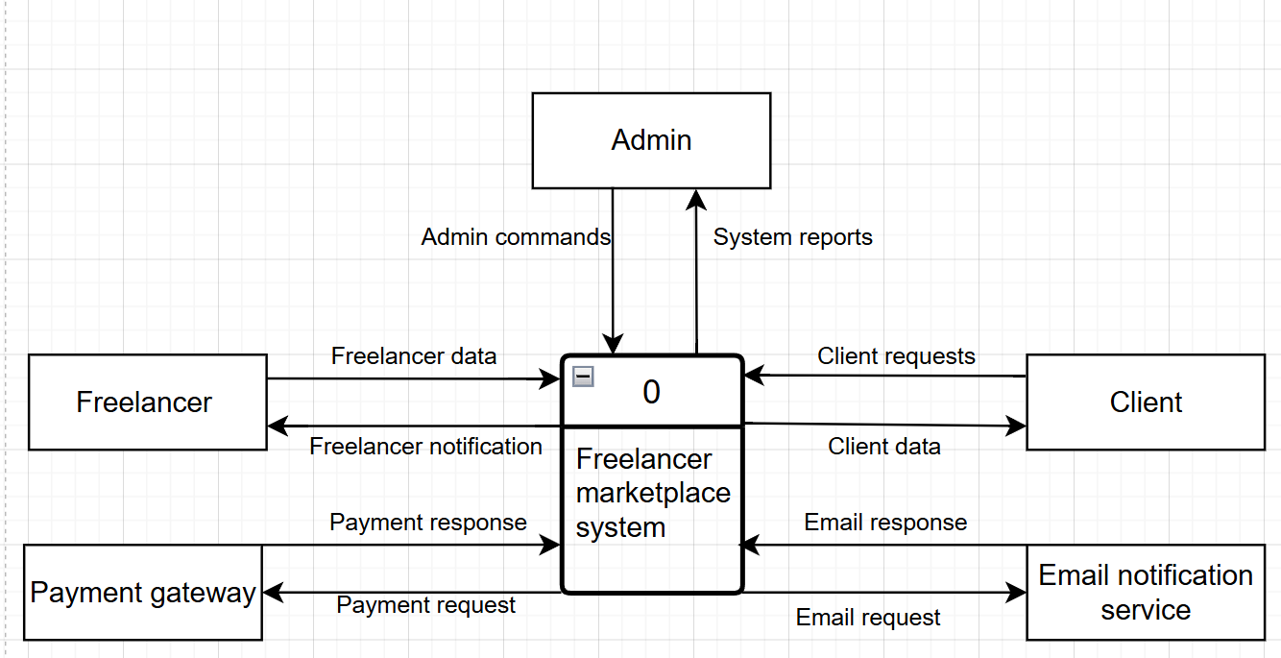

Dataflow Diagram with various Levels
Level 0
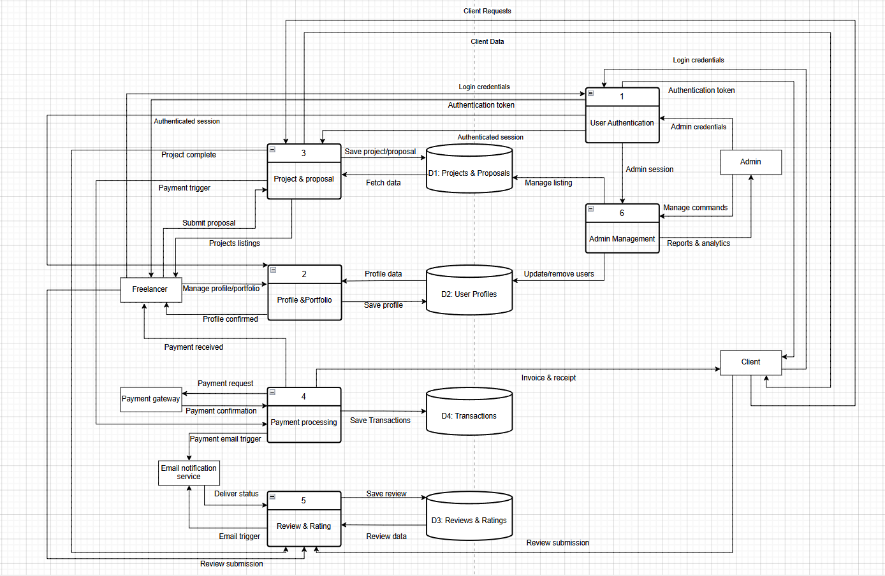
Level 1 Process 3 -- Project & Proposal Management:
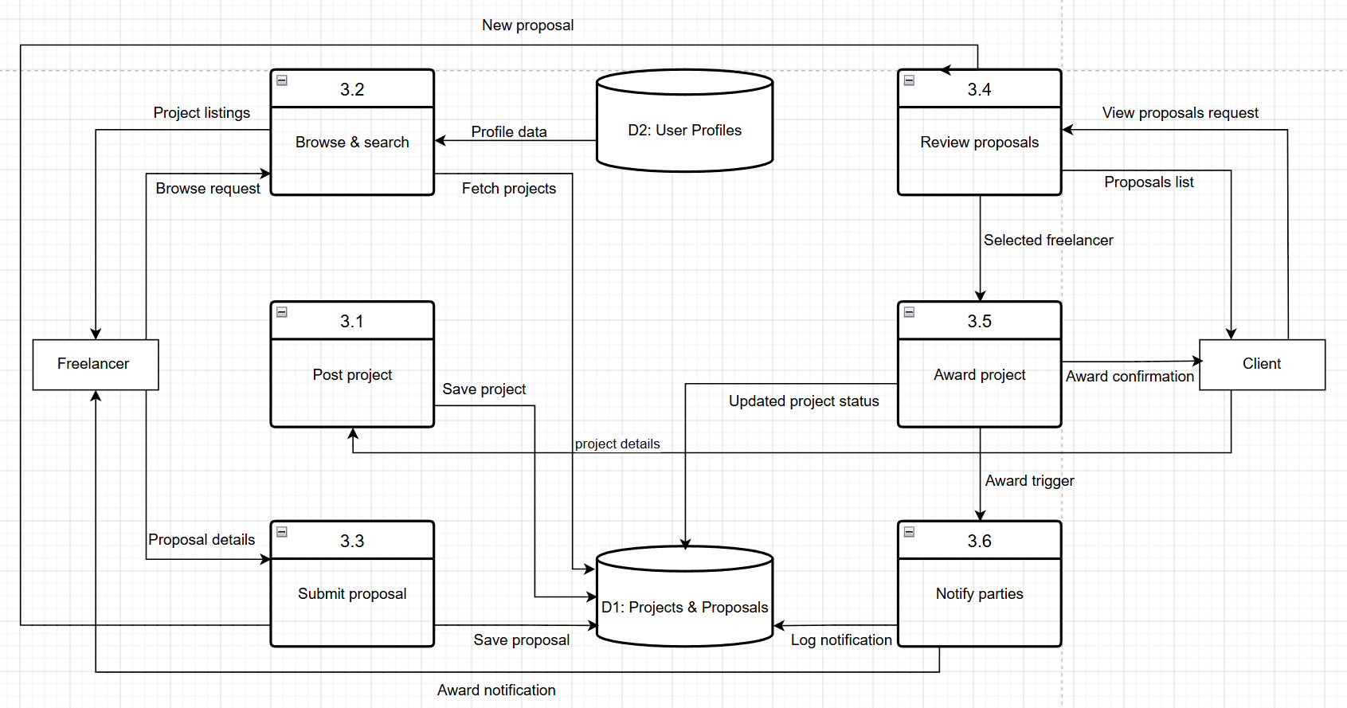
Level 1 Process 4 -- Payment Processing:
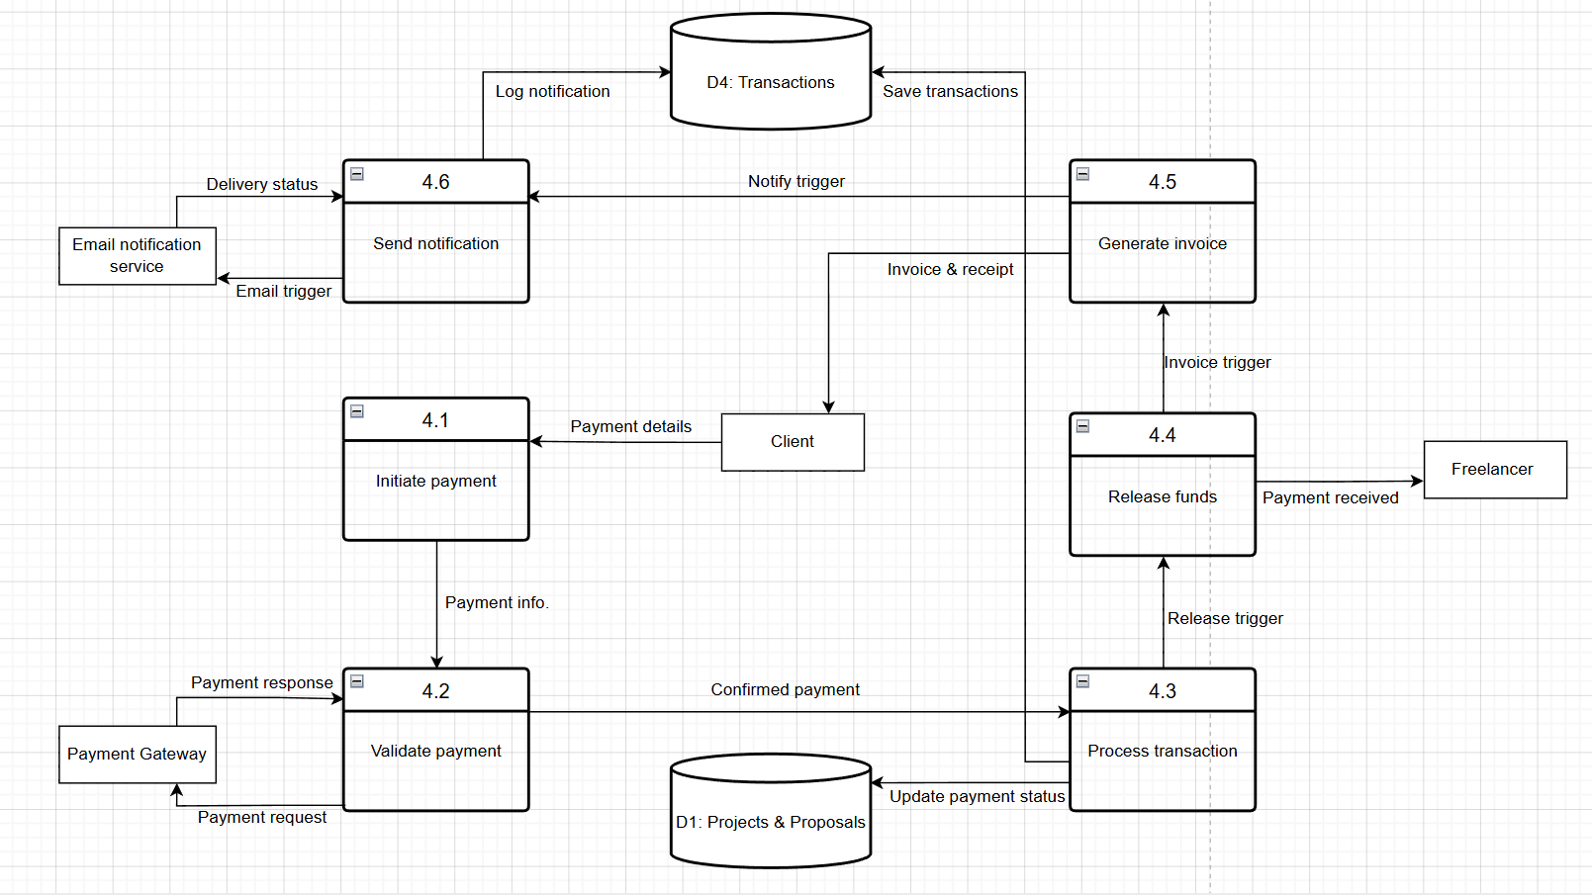

Level 2 Process 3 -- Project & Proposal Management:
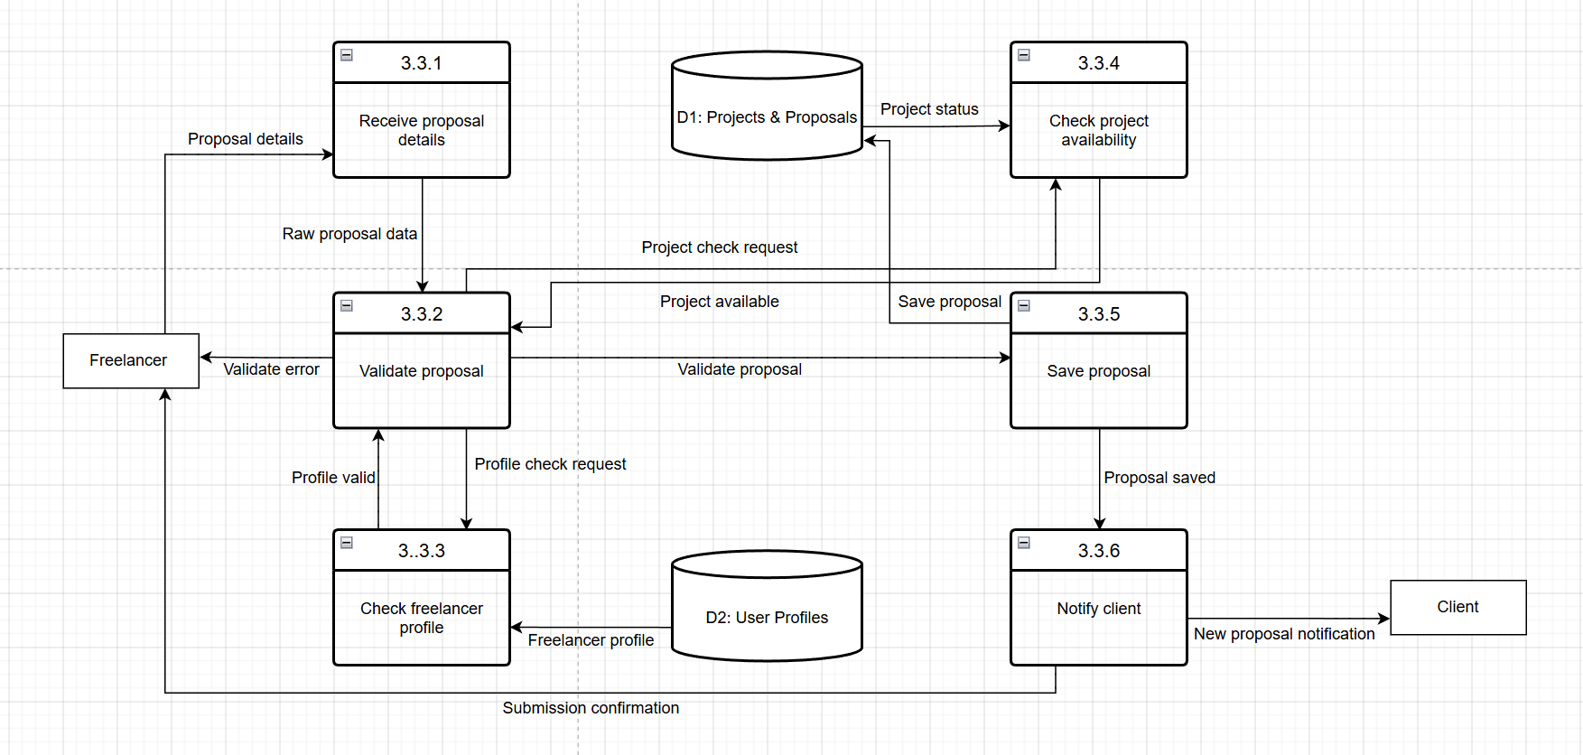
Level 2 Process 4 -- Payment Processing:
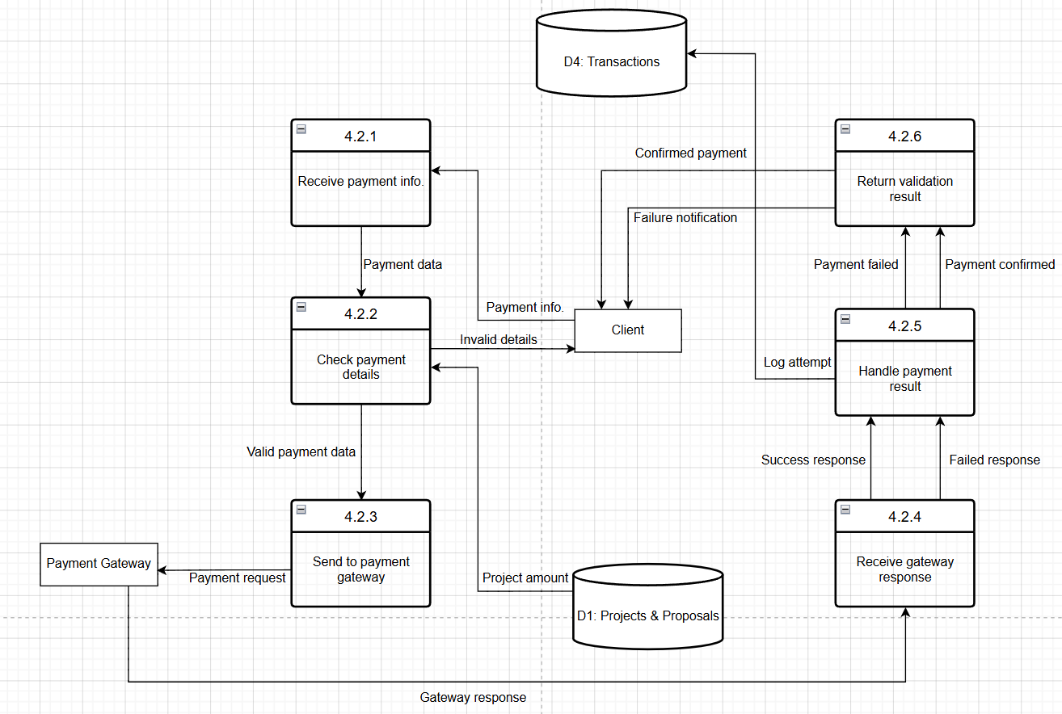

Activity Diagram
Illustrates the core workflow of the Freelancer Marketplace, covering the full lifecycle from user login through project posting, bidding, work delivery, and review submission. The diagram captures both the client and freelancer paths, their point of convergence when a project starts, and the revision loop if the client requests changes before approving the final deliverable.
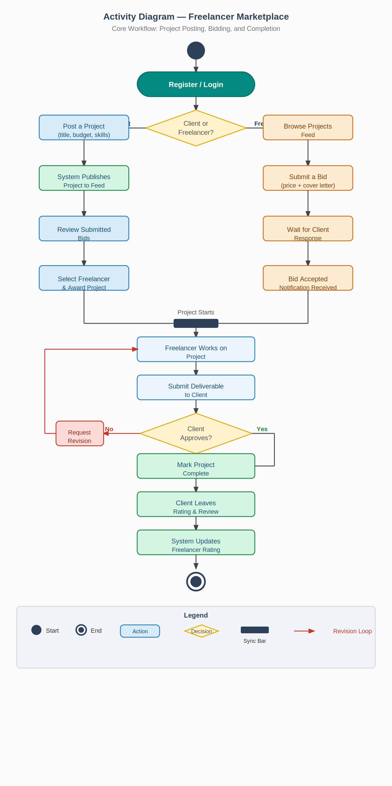

ERD Diagram
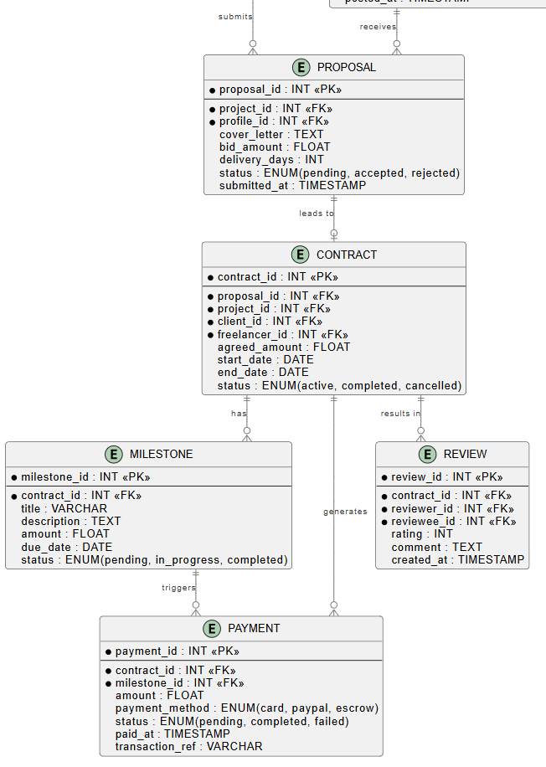
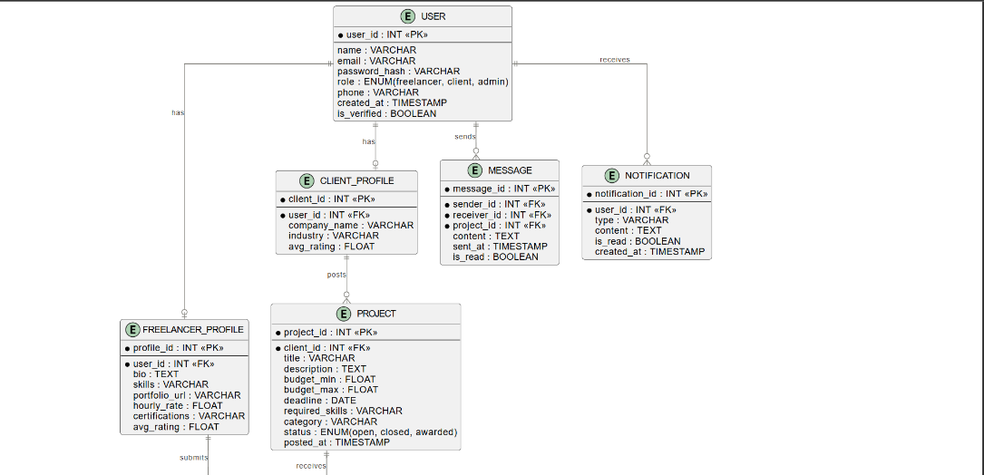

System Acquisition Strategy
The system acquisition strategy defines how the Freelancer Marketplace platform will be obtained, built, and deployed. After evaluating three possible approaches, the development team selected In-House Development as the primary acquisition strategy based on a structured comparison of alternatives.

The Alternative Matrix
The Alternative Matrix compares three possible solutions for building the Freelancer Marketplace against key evaluation criteria. Each alternative is scored from 1 (poor) to 5 (excellent) per criterion. The alternative with the highest total score is the recommended approach.
Alternatives Considered
Alternative 1 — In-House Development: Build the platform from scratch using our own development team.
Alternative 2 — Packaged Solution: Adapt an existing freelance platform template or white-label product.
Alternative 3 — Outsourcing: Hire an external development agency to build the platform.
Criterion | Weight | Alt 1: In-House |  | Alt 2: Packaged |  | Alt 3: Outsource
 |  | Score | Weighted | Score | Weighted | Score | Weighted
Customization | 20% | 5 | 1.00 | 2 | 0.40 | 3 | 0.60
Development Cost | 15% | 3 | 0.45 | 4 | 0.60 | 2 | 0.30
Time to Deploy | 10% | 3 | 0.30 | 5 | 0.50 | 3 | 0.30
Scalability | 15% | 5 | 0.75 | 3 | 0.45 | 3 | 0.45
Security & Control | 15% | 5 | 0.75 | 3 | 0.45 | 3 | 0.45
Maintenance | 10% | 4 | 0.40 | 3 | 0.30 | 2 | 0.20
IP Ownership | 10% | 5 | 0.50 | 2 | 0.20 | 3 | 0.30
Team Feasibility | 5% | 4 | 0.20 | 4 | 0.20 | 3 | 0.15
TOTAL | 100% |  | 4.35 ✓ |  | 3.10 |  | 2.75

Based on the weighted scores, Alternative 1 (In-House Development) achieves the highest total score of 4.35, making it the recommended approach for the Freelancer Marketplace. It scores highest in the most critical criteria: customization, scalability, security, and IP ownership.
Design Strategy
For the Freelancer Marketplace, we chose In-House Development as our design strategy. The two alternatives to purchasing a packaged solution or outsourcing development were considered but ruled out for practical reasons.

Packaged solutions like existing freelance platform templates are built for generic use cases. They do not support the specific combination of features we need: custom skill-category filtering, portfolio showcasing tied to service listings, and a rating system that feeds into search ranking. Adapting a packaged product to match our requirements would require more effort than building from scratch.

Outsourcing was not practical given that the platform's core value comes from how its components interact. Handing that to an external party introduces communication overhead and makes it difficult to iterate quickly when requirements change, which is common early in a product's development.

In-house development gives us direct control over the product. We can prioritize features based on user needs, adjust the design as we test, and ensure the matching logic between freelancers and project postings works the way the business intends. Since the marketplace model depends heavily on trust through reviews and verified profiles having full ownership of how that data is handled is important.
Factor | In-House | Packaged | Outsource
Fits our specific features | Yes | Partial | Depends
Full control over product | Yes | No | No
Easy to modify later | Yes | Limited | Slow
Owns the data & logic | Yes | Partial | Shared

Test Scenarios

Scenario 1 — Freelancer Registration and Profile Setup
 | Details
What is being tested | A new user registers as a freelancer, fills in their profile, selects skill categories, and uploads a portfolio item.
Steps | 1. Open the registration page and enter valid details. 2. Select Freelancer as account type. 3. Confirm email. 4. Add skills, bio, and upload a portfolio sample. 5. Save and view the public profile.
Expected result | All entered data is saved correctly and appears on the freelancer's profile page.
Pass condition | Profile displays the correct skills, bio, and portfolio item.
Fail condition | Any data is missing or the profile page fails to load.
Type of testing | Functional Testing (Black-Box) — we are testing what the system does from the user's perspective, not how it does it internally.

Scenario 2 — Client Posts a Project and Freelancers Submit Bids
 | Details
What is being tested | A client posts a project with a description, required skills, and budget. Freelancers find and bid on the project.
Steps | 1. Client logs in and posts a project with all required fields. 2. Verify the project appears in the freelancer discovery feed. 3. Two freelancers submit bids with different prices. 4. Client opens the bids dashboard and views both proposals.
Expected result | The project is visible to freelancers, both bids are correctly linked to the project, and the client sees them in their dashboard.
Pass condition | Both bids appear under the correct project with the right freelancer details.
Fail condition | Project does not appear in the feed, or bids are missing or attached to the wrong project.
Type of testing | Integration Testing — this scenario connects multiple parts of the system: the posting module, the search/discovery feed, and the bidding module. We are verifying they work together correctly.

Scenario 3 — Client Leaves a Review After Project Completion
 | Details
What is being tested | After a project is marked complete, the client submits a star rating and written review for the freelancer.
Steps | 1. Both client and freelancer mark the project as complete. 2. Client navigates to the project and selects 'Leave a Review'. 3. Client gives a 5-star rating and writes a review. 4. Review is submitted. 5. Check the freelancer's profile — the review should appear and the average rating should update. 6. Try submitting a second review for the same project (should be blocked).
Expected result | The review appears on the freelancer's profile, the average rating is updated, and submitting a duplicate review is not allowed.
Pass condition | Review visible on profile, correct average rating shown, duplicate blocked with a message.
Fail condition | Review does not appear, rating is wrong, or a duplicate review is accepted.
Type of testing | System Testing / User Acceptance Testing (UAT) This tests the full end-to-end flow from a real user's perspective also verifies a business rule: one review per completed project.

User Interface Design
(System screens, menus and options design)
Link: https://diaa-eldeen2004.github.io/FreeLance-system_analysis-/

Link for the code: https://github.com/diaa-eldeen2004/FreeLance

